Expanse Services

What to Expect

Document Status: Mostly Complete, pending formatting cleanup and web implementation
Project Approach and Methodology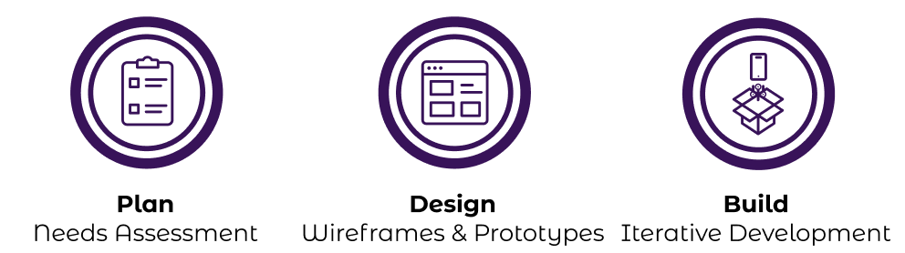
Our streamlined process seamlessly guides your project from vision to reality. Our three core phases – Planning, Design, and Build – ensure clarity, efficiency, and continuous improvement

We begin with a consultation and needs assessment to gather insight on your requirements, goals, and challenges. Next, we transform your vision into strategic designs that outline the user interface, user experience, functionality, and technical architecture. Throughout the build process, which encompasses planning, design, and development, we employ an iterative agile approach. This involves prioritizing and delivering the most critical and valuable elements first, with the flexibility to adapt to changes and execute ongoing improvements. This ensures that your project keeps moving forward delivering you the features and functionality you need to achieve your goals as soon as possible while minimizing risks, expediting time to market, and optimizing cost efficiency.

Table of Contents
Table of Contents 2
Planning and Consultation Phase 4
Round 1: Embark on Your Digital Journey: Discussing Your Vision 4
Step 1: Articulating Your Vision 5
Step 2: Define the Project Scope and Deliverables 5
Step 3: Exploring Tools, Technology, and Design Options 5
Step 4: Preliminary Timeline, Budget, and Rate Estimations 6
Addressing Concerns and Questions 6
Establishing Next Steps 7
Round 2: Crafting a Detailed Project Charter 7
User Experience Planning 7
Expanding on Project Requirements, Scope, and Delivery 8
Discussing Integration Requirements 8
Prioritizing Requirements and Understanding Value 8
Establishing Testing Strategies 9
Defining Release Preferences 9
Design Recipes 9
Creating Wireframes 9
High-Level Technical Architecture 9
Moving Forward 10
Design and Strategy Phase 10
Design First, Build Smarter 10
Tools and Techniques 11
Unveiling the Technical Blueprint 13
Development, Building, and Iteration Phase 16
Coding with Modern Technology for Fast and Scalable Development 16
Planning as a Continuous Service 16
Why Iteration Matters 16
Traditional Iteration Cycle 17
Every project is unique. 17
Predicting and Managing Development Complexity: Point Estimates 17
Cloud Hosting and Continuous Deployment 19
Multi Environment Setup 19
Continuous Deployment 20
Expanse Hosting and Development Solutions 20
Agile Sprints and Kanban for Optimal Development 21
Agile Ceremonies 23
Boosting Engagement and Delivering Results with Agile 23
Sprints: Focused Iterations with Tangible Goals 23
Point Estimates: Complexity > Time 24
Smaller Tasks: Enhancing Communication and Maintaining Momentum 24
Continuous Improvement and Collaboration 24


Planning and Consultation Phase

Round 1: Embark on Your Digital Journey: Discussing Your Vision
The first step marks the beginning of an exciting journey to transform your vision into a reality. This crucial step establishes the initial groundwork for our collaboration—a high-level review to begin aligning with your goals, expectations, and needs.

Step 1: Articulating Your Vision
First, I listen. Every journey begins with your story – I’ll hear you share your ideas, uncovering your goals, objectives, and concepts for the project. I will actively listen and ask clarifying questions to gain a comprehensive understanding of your requirements and aspirations. Existing requirements or designs provide a great starting point for our journey forward. If none exist yet, that’s an opportunity to explore possibilities and create something uniquely suited to your vision.

Step 2: Define the Project Scope and Deliverables
In this phase we focus on capturing initial written notes to form a high level understanding of the project. Together, we’ll start to define the project scope, outlining the important features, functionalities, and deliverables that will bring your dream to life.

Step 3: Exploring Tools, Technology, and Design Options
I will provide insights into preferred technology stacks and design approaches that align with your project's requirements and aesthetic preferences. This exploration will help you understand the technical feasibility and start to envision the overall look and feel of your website or application.
You’ll also gain a deeper insight into the advantages of working with me, including modern tools, technologies, and expansive knowledge. We’ll leverage these strategies to bring your project to life transforming your ideas into solutions that inspire confidence and trust. Key benefits include:
- Time and Cost Savings: Utilizing modern tools and technologies to streamline workflows and reduce costs, ensuring your project efficiently without compromising quality.
- Reusable Code and Standardized Structures: Accelerating development by leveraging efficient, reusable components that improve efficiency, maintain consistency, and support scalability for future needs.
- Higher Quality and Scalability: Ensuring your project is built to grow and adapt to future demands.
- Improved Security: Incorporating best practices to safeguard your application and data.
- Strategic Insight and Expertise: Leveraging extensive knowledge of industry trends, tools, and methodologies to guide informed decisions.
Example Tools and Resources Explored
- Development Languages and Technologies: Ensure fast, reliable, and scalable solutions while maintaining exceptional quality.
- Cloud Hosting and Services: Harness the power of platforms like Google Cloud Platform and AWS to support unlimited scalability, peak performance, and seamless integration with cutting-edge tools.
- AI Integration: Utilizing artificial intelligence is a preferred strategy to accelerate development, streamline content creation, and enhance communication.
- Productivity and collaboration tools: Adopt tools that improve team communication, foster collaboration, and boost overall productivity.
- Content Marketplaces: Explore options to find starter or permanent content to save time and money, spark ideas, and build your project in record time.
We'll choose the most effective tools and approaches to set your project up for success.

Step 4: Preliminary Timeline, Budget, and Rate Estimations
We will explore the early ballpark figures for your project’s timeline and budget. While these are early approximations based on the information available, the goal is to align expectations and ensure we’re on the same page about the general scope of the project. Rate estimates, where applicable, will also be discussed to provide a clearer picture of costs. If there are detailed designs or mockups already in place, we can refine these estimates further. This initial discussion serves as a starting point, giving us a shared understanding before diving into more detailed planning in the next phases.

Addressing Concerns and Questions
Your questions and concerns are always welcome and will be addressed throughout the project—not just during this stage. Software development, especially for complex projects, often involves adjustments and pivots, and I’m here to navigate those with you.
Questions will be answered to the best of my knowledge, providing thoughtful responses to guide the process. Together, we’ll work towards clarity and alignment, ensuring a smooth and productive collaboration.

Establishing Next Steps
This phase concludes with a high-level discussion of the project’s budget and approximate timelines. Some details may need further refinement and formalization, but we’ll establish initial expectations to ensure we’re aligned and on the right path. Additionally, follow-up actions and clear communication channels will be outlined to support collaboration and next steps.
As you embark on this exciting journey, I’m here to guide and support you at every turn. Together, we’ll take the first steps toward transforming your vision into a successful digital solution, navigating each stage with expertise, dedication, and a shared commitment to success.

Round 2: Crafting a Detailed Project Charter
In this phase, we dive deeper into the project’s scope, deliverables, and timeline, refining them with greater clarity and precision to ensure alignment with your vision and objectives. We will also create wireframes, dive into design details, and focus on the flow and functionality of your project. This step paves the way for deeper insights and lays the groundwork for your digital blueprint.

User Experience Planning
User experience (UX) planning is the process of designing a positive and effective experience for users interacting with a product, service, or system. It involves understanding user needs, behaviors, and motivations, and using that knowledge to create a design that is both user-friendly and aligns with business goals.
We begin by exploring high-level, important aspects such as identifying your target audience, understanding their intentions, where they’re coming from, why they are visiting, and what they hope to achieve. This early exploration often includes creating personas and mapping out user journeys.
User experience planning helps to craft a product that optimally resonates with the audience and weighs into decisions of how to present information and experiences that align with the audience's preferences and goals. Extraordinary art might go underappreciated if shown to an audience unfamiliar with its context. Similarly, presenting an apple to hungry but predominantly carnivorous connoisseurs may not be the ideal choice. While every interaction offers an opportunity to learn and adapt, effective user experience planning increases the likelihood of delivering a product that meets the audience’s needs and aligns with the broader objectives.
Key benefits of include:
- Improving user satisfaction and adoption
- Enhancing communication
- Designing intuitive, easy-to-use software
- Reducing errors and frustration
- Clarifying project requirements and aligning expectations
- Boosting user productivity
As part of this process, we may also explore strategy for information architecture, accessibility, content strategy, and interaction design. This is an evolving process, and we will continuously revisit and improve the user experience throughout the project lifecycle.

Expanding on Project Requirements, Scope, and Delivery
Through thoughtful collaboration and ongoing review, we refine and expand upon the project’s scope, requirements, deliverables, goals, budget, and risk mitigation strategies. We also may dive into more detail on business processes in order to further define and truly understand the requirements. As part of this phase, we will also begin forming initial tickets, laying the groundwork for the development process.

Discussing Integration Requirements
We discuss the integration needs of your project, including social media platforms, third-party APIs, databases, and legacy systems. Depending on your project’s requirements, if there is a need to integrate with your existing infrastructure, we will explore how and why, then develop a strategy for incorporating it. We also address any external APIs or data sources, gather relevant documentation, review schemas, and discuss future support considerations. Additionally, we talk through testing requirements and any potential liabilities associated with integrating external dependencies.

Prioritizing Requirements and Understanding Value
To prepare and coordinate design and development we will identify which features and content are the most valuable, which ones are urgent, which ones can wait. If known we will also discuss the degree to which they are valuable and other variables at play.
This is important because it helps establish the sequence for which these items will be designed and developed. It also helps determine the placement, and prominence of content, when and how to start development, how much scrubbing to do, and effectively allocate resources.

Establishing Testing Strategies
We discuss requirements, preferences, and methodologies for testing to establish a flexible quality assurance plan tailored to your project’s needs. In this phase, we’ll assess the appropriate balance of timing and intensity for testing, ensuring it aligns with the scope, complexity, and timeline of your project.

Defining Release Preferences
We work together to determine the desired release cadence—whether it's continuous deployment or scheduled releases. This approach may adapt based on project milestones and shifting needs to ensure the best release strategy at every stage.

Design Recipes
We discuss your design preferences, serving up options like color palettes, typography, and aesthetic direction to craft a design strategy tailored to your brand. I ask questions like, "Is there a particular flavor or theme you’d like to go for?" If you already have established tastes, we’ll refine and build on those ingredients. If not, we guide you through the process by presenting samples to inspire and help shape your vision for product design.

Creating Wireframes
We utilize wireframes to visualize the layout and structure of key pages, providing a rough outline of the user interface. This low-fidelity approach allows for early feedback and iteration.

High-Level Technical Architecture
We collaborate to decide on the high-level technical architecture, including the choice of programming languages, frameworks, and tools. This decision is based on the project's requirements, scalability needs, and future growth plans.

Moving Forward
Once we have collaboratively crafted a well thought out project charter that captures your vision and objectives, all parties come together to sign on and we begin to move forward into the next phase. This project charter acts as a guiding light throughout the project’s development, ensuring your goals remain at the forefront and guide us toward a solution that aligns with your vision.

Design and Strategy Phase
Envisioning Success: Transforming Your Charter into Mockups and Technical Specifications
Before delving into the intricacies of coding, we embark on a collaborative design journey, encompassing both visual and technical aspects. We utilize the power of Figma, an interactive prototyping platform, to translate your vision into mockups. This collaborative space allows us to refine and iterate on the design before committing to code. In tandem, we lay the foundation for a technical architecture, exploring the technical feasibility of design elements, while planning some of the architectural roots of your application.

Design First, Build Smarter
Visual design is a critical step that benefits every stage of the project. By creating visual mockups before coding begins, we save time, save money, and improve quality. Mockups act as a common language that fosters clear communication, helps visualize complex ideas, and refines project requirements. This approach not only solidifies our alignment but also provides valuable opportunities for collaboration and feedback before diving into implementation.
While design is an ongoing process throughout the application development lifecycle, a significant portion—especially the Minimum Viable Products (MVPs)—is typically drafted in the early stages. The level of detail in the design varies by project: some require quick sketches to get started, while others demand meticulous detailing. The design process paves the way for development by providing a clearer picture and facilitating comprehension and estimation. This is especially helpful to gain a firmer grasp on complex subjects and reduce the amount of changes for cosmetics.

Tools and Techniques
Design is a key factor for successful digital products. My approach combines powerful tools and resources to create visually compelling, functional, and user-focused designs. Below is a breakdown of some core components focused on during the design process.
- Collaboration: Figma stands out as my preferred design tool due to its phenomenal collaboration experience. Its real time joint interactivity and editing combined with its commenting system greatly improve the overall experience.
- Designing for User Experience: With user experience in mind I design intuitive layouts, navigation structures, and process flows that enrich user interactions.
- User Interface Components: I design individual user interface components considering usability, reusability, accessibility, and visual appeal. Striving to maintain consistency throughout the project, ensuring that every element—from intuitive buttons to purpose driven icons—are aesthetically pleasing and seamlessly integrated, enhancing the user experience.
- Content and Assets: I identify, gather, and create relevant content, including text, images, graphics, animations, and videos, to ensure an engaging user experience. This content serves as the foundation for crafting compelling narratives, representing your brand, and promoting effective communication.

Design Example 1: Work In Progress Wireframes / Design
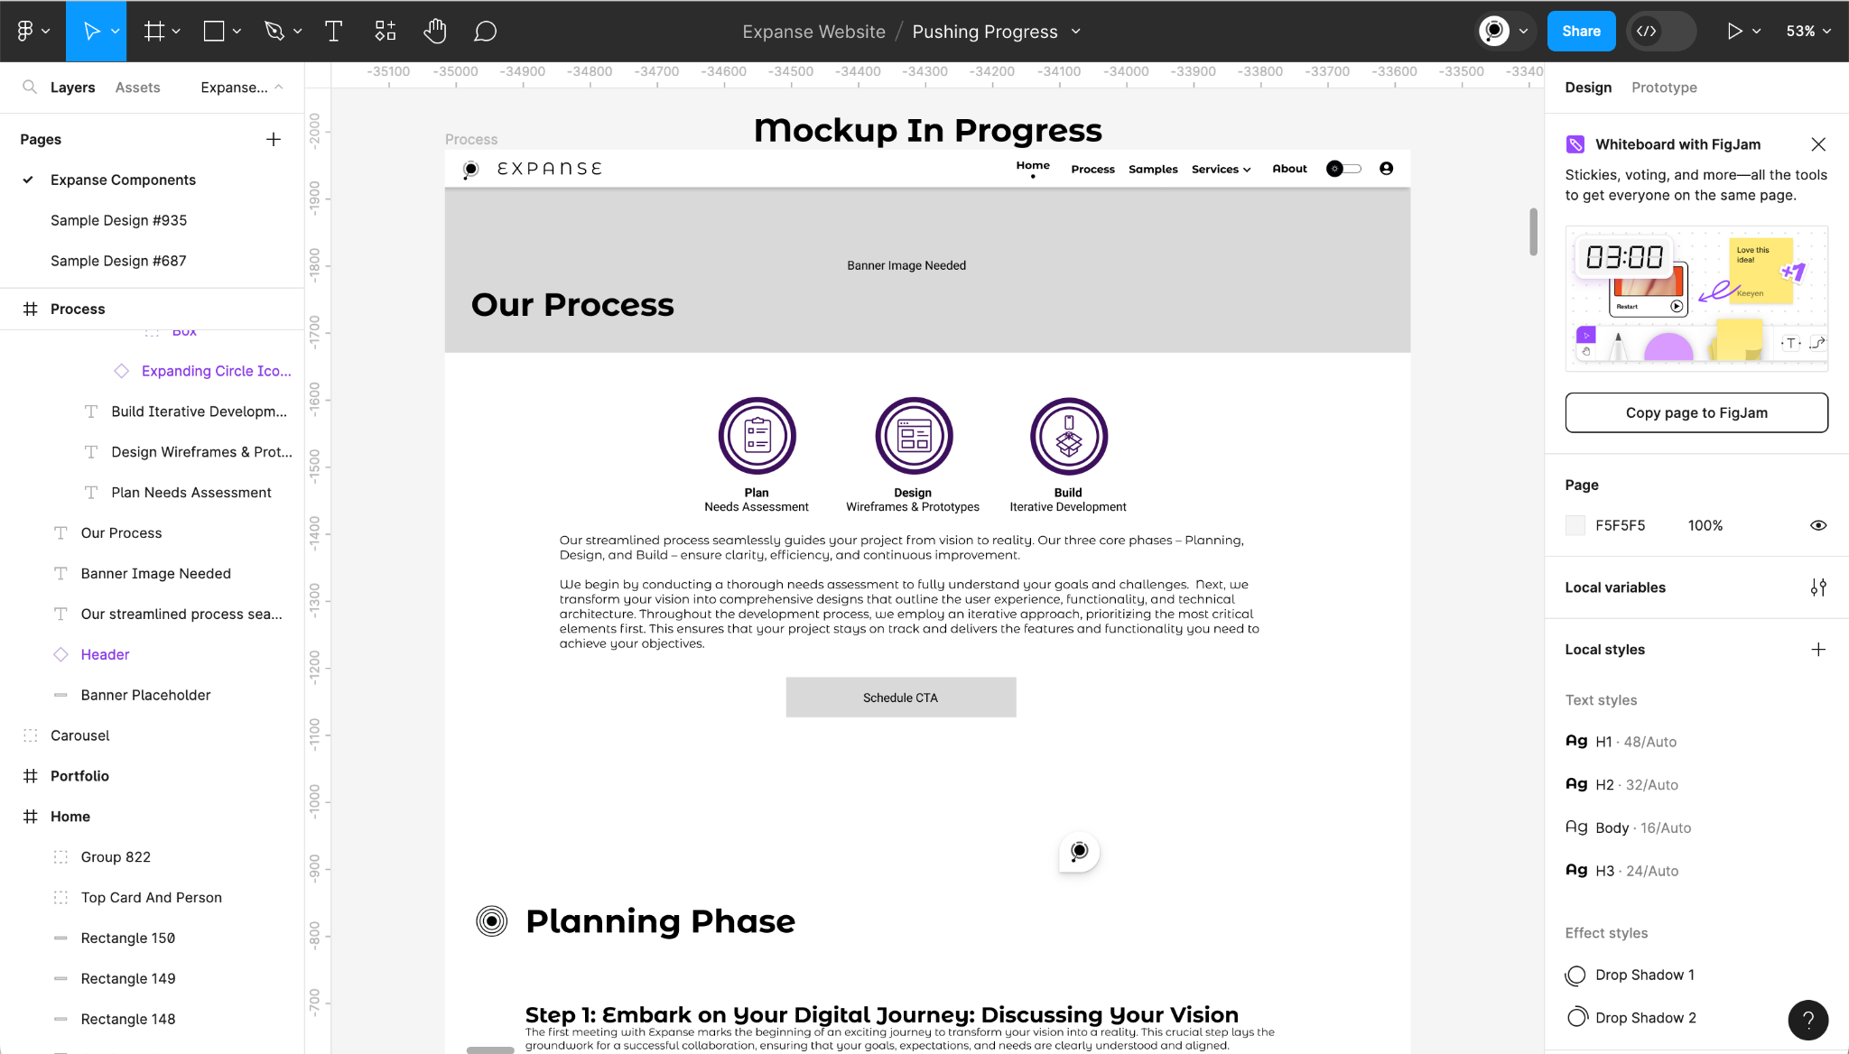
Design Example 2: Component Development, Higher Detail
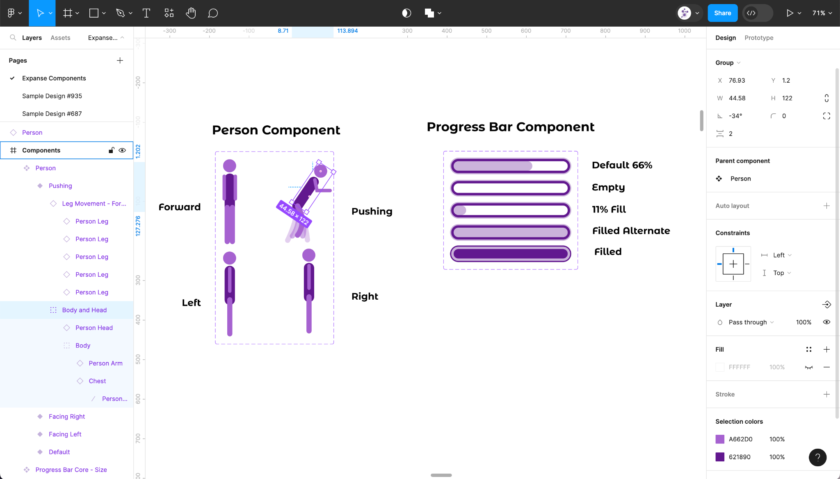

Unveiling the Technical Blueprint
Alongside the construction of the visual elements, I also lay the groundwork for its technical backbone. This includes:
- Designing The System and Infrastructure: I define the infrastructure of your website or application ( servers, hosting, databases, integrations, etc ), ensuring optimal performance, scalability, and security. I account for factors like expected traffic volume, high value and high usage features, data storage, and security protocols to ensure that your application can handle user demand and keep information private and secure.
- System and Architecture Design: I plan the application’s structure, considering options such as microservices, monolithic, or serverless architectures, along with database setup, component definitions, deployment pipelines, testing strategies, and analytics plans.
- Defining API Design Specifications: I define the initial API design specifications and schema to support the known features/requirements and mockup. I also take into account details regarding integrations and utilization of third party apis and data sources.
- Database Design and Data Modeling: Based on the requirements and mockup, I begin crafting data models and database schemas. This includes creating ERD diagrams, defining data dictionaries, and preparing the database architecture to support the application’s needs.
- Defining Key Test Cases: If there are critical areas of the system that require focused testing, I highlight them early in the process. This includes defining specific test cases, their expected outcomes, and the requirements for the tests to pass.
- Supportive Documentation Plan: I outline the plans for additional resources like Build and Deployment Guides, Business Process Documentation, User Manuals, Quick Start Guides, FAQs, Release Notes, and Version Control Processes to ensure smooth deployment and future maintenance.
Example Technical Design: API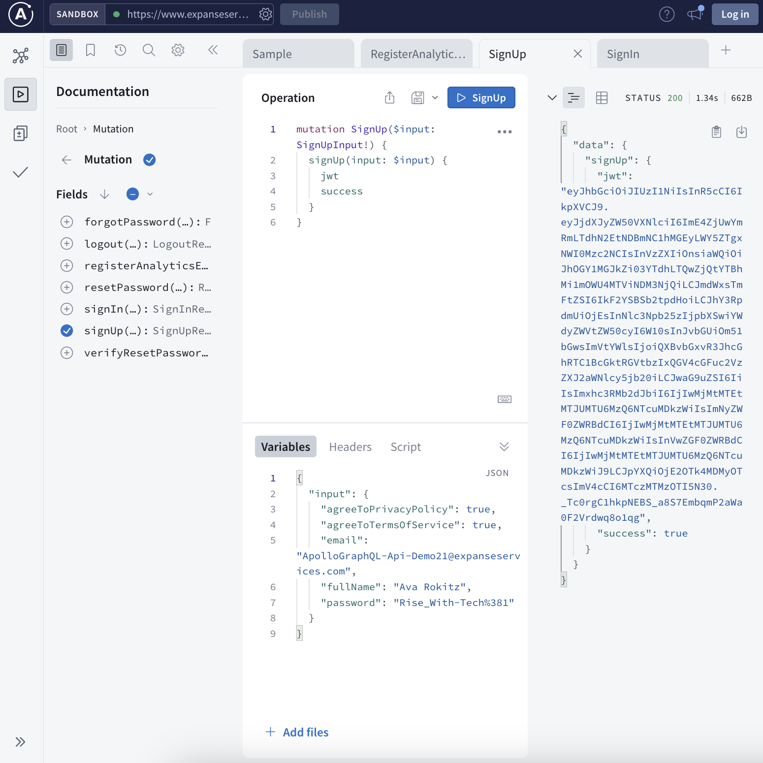
Example Technical Specification Document
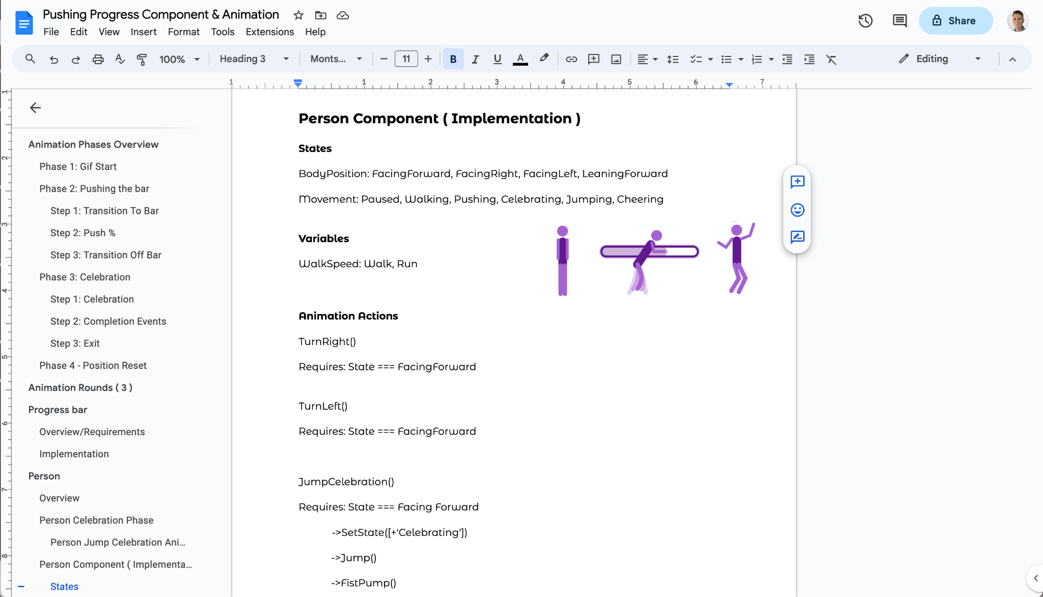

Development, Building, and Iteration Phase
After the initial project charter is created and the design is ready, we move on to development. Utilizing modern tools and technology we develop your applications in record time, but all three components—planning, design, and development—are ongoing processes. We utilize Agile Sprints for short, focused iterations with clear, achievable goals and estimate task difficulty using points to enhance motivation and predictability. Practicing agile ceremonies fosters effective communication, maintain organization, and help ensure processes run smoothly and efficiently.

Coding with Modern Technology for Fast and Scalable Development
Powered by state-of-the-art technology, my development process creates applications with lightning speed. With JavaScript and TypeScript as my foundation, I specialize in delivering products that offer performance, scalability, and reusability.
Preferred Technologies
- UI: React, Angular, JavaScript
- Server Side: Node.js, Nest.js, Express
- Databases & Data: MySQL, MongoDB, JSON
- Open Source & Tooling: OpenAI, Git, Webpack
- Design Patterns: GraphQL, REST, Serverless

Planning as a Continuous Service
Planning never truly ends; it adapts and evolves alongside the application as new information is discovered, and fresh perspectives are gained. By investing time early to explore areas of greatest complexity or risk, we minimize surprises down the road.

Why Iteration Matters

Software is inherently complex. Achieving perfection on the first attempt is rare, and requirements often shift as concepts take shape and solutions are tested. Revisiting project details at different points in the journey often reveals opportunities, insights and improvements that weren’t initially apparent. Agile methodologies embrace this natural evolution and support adaptation and continuous improvement as projects come to fruition.

Traditional Iteration Cycle
My work cycles follow an iterative structure:
- 1) Sprint Execution: Typically, I work in 2-week sprints (or other timeframes depending on the project), focusing on a preselected set of features or tasks.
- 2) Pause to Reflect: After each sprint, I pause to plan, reflect, and adapt based on outcomes and feedback.
- 3) Adapt and Evolve: New information is continuously uncovered during the development process, and updates are reflected in planning and cleanup sessions.

Every project is unique.
Some projects need more detailed planning up front, while others aim to begin development as soon as possible. Some projects come with more complexity while others are more straightforward. The principles discussed here aim to provide a general framework.

- For larger, long-term, or complex projects, this iterative approach becomes essential for navigating uncertainty and adapting to changes.
- For smaller, more straightforward projects, you may notice less deviation from the original plan, but iteration still unlocks additional value.

Predicting and Managing Development Complexity: Point Estimates
Effective project management is at the heart of my development process. By breaking tasks into manageable pieces and assigning point values to estimate complexity, I enhance productivity and improve communication.
Story points are like comparing the "size" of tasks.
- Small tasks get a small number (like 1 or 2): These are like building a small closet – relatively simple and quick.
- Medium tasks get a medium number (like 3 or 5): These are like building a regular bedroom – more complex than a closet, but not huge.
- Large tasks get a larger number (like 9 or 18): These are like building the entire kitchen or a master suite – significantly more work and complexity.
Why do we do this instead of using hours?
- It's easier to compare than to guess hours: It's easier to say "this is about twice as much work as that" than to accurately predict how many hours something will take, especially when dealing with complex software.
- Things change: Sometimes unexpected problems pop up during construction (or software development). Using relative sizes (story points) helps us adjust without having to re-estimate everything in hours.
- It helps us plan better: By tracking how many "points" we complete each week (like how many "rooms" we finish), we can get a good idea of how long the whole house (project) will take.
Key benefits for you:
- Better predictions: I can give you more reliable estimates of when features will be ready.
- More flexibility: I can adapt to changes more easily without throwing off the whole schedule.
- Clearer progress tracking: You can see how many "points" are being completed each sprint, giving you a better sense of how the project is moving forward.

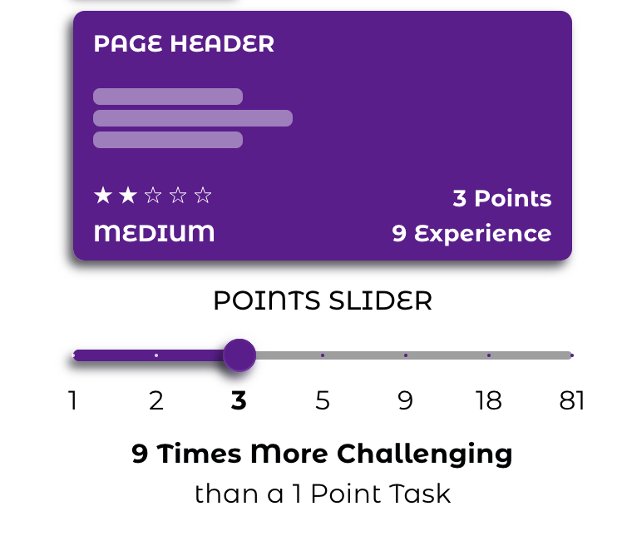

Cloud Hosting and Continuous Deployment
We provide expert assistance in deploying your application to a cloud environment, offering robust hosting setups and seamless launches. From traditional servers to serverless functions and content hosting, your application is built for success and scalability.
For ongoing development, I offer continuous deployment solutions, allowing updates to be frequently pushed to development, testing, and production environments as appropriate. This enables faster feedback loops, thorough reviews, and effective testing cycles.

Multi Environment Setup
An environment is a controlled setting where apps are built, tested, and run at different stages of development. This may be accessed by visiting a link such as dev.yourwebsite.com
These are environments where you can view and use various versions of your application. This multi environment setup supports frequent deployments, enabling continuous improvement and faster feedback loops.
- Production Environment: For live code accessible to users.
- Staging Environment: For reviewing and testing specific code versions before pushing to production.
- Development Environment: Frequently updated during active development.

Continuous Deployment
Continuous deployment is an automated process for releasing updates to software quickly and efficiently. This ensures that changes are integrated and tested in real-time, streamlining the development workflow.
Key Benefits include:
- Immediate visibility into changes in testing or development environments.
- Faster iteration cycles for resolving issues and implementing improvements.
- Enhanced communication and information flow between teams.

Expanse Hosting and Development Solutions
Expanse offers a range of solutions to meet your hosting and deployment needs including:
- Cloud Hosting: Services such as Google Cloud Platform (GCP) and Amazon Web Services (AWS).
- Serverless Computing: Solutions using AWS Lambda, Google Cloud Functions, and other providers.
- Streamlined Development Processes: Including version control strategies for branching and committing, deployment pipelines, and continuous integration.
This Includes:
- Server Setup: Physical machines, RAM, CPUs, load balancing, DNS, and common backend configurations.
- Data Repositories: Relational databases, NoSQL databases, and file system storage.
- Cloud Service Implementations: Text messaging, emailing, text-to-speech functionality, document scanning, generative AI integrations, image classification, and more.

Agile Sprints and Kanban for Optimal Development
I follow an agile approach, using either Sprints or Kanban, depending on the project’s needs.
Sprints: Development is organized into two-week increments where specific goals and features are prioritized. After each sprint, we reflect, adapt, and plan for the next iteration. Code deployment often follows sprint completion.
Kanban: An alternative approach focused on continuous delivery, prioritizing tasks as they come in. Less frequently utilized but good for certain circumstances.

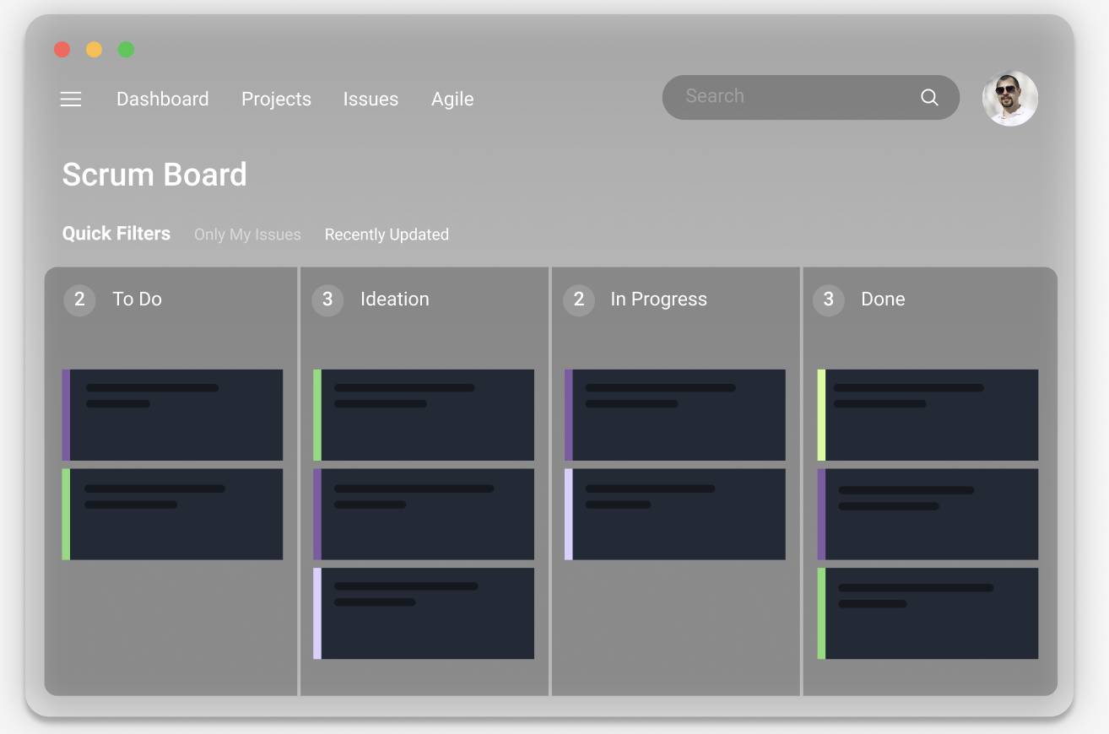

Example Tools - Jira: My preferred project management tool for tracking tickets, estimating complexity, and organizing tasks. It helps keep projects organized and greatly improves communication and status tracking.
Explore Samples Below! Below you can find example screenshots of the Jira interface in use. These images depict typical software development work and the types of information you’ll see on a weekly basis. This includes:
- Standard Ticket Types:
  - Tasks: Single actionable items
  - Stories: Features or related functionality groups.
  - Epics: Large categories of stories or broader project goals.
- Key Ticket Details: Descriptions, statuses, priority, point estimates, and associations.
- Sprint Boards: Visuals of active work and real-time progress on committed tasks.
Example Ticket Management System in use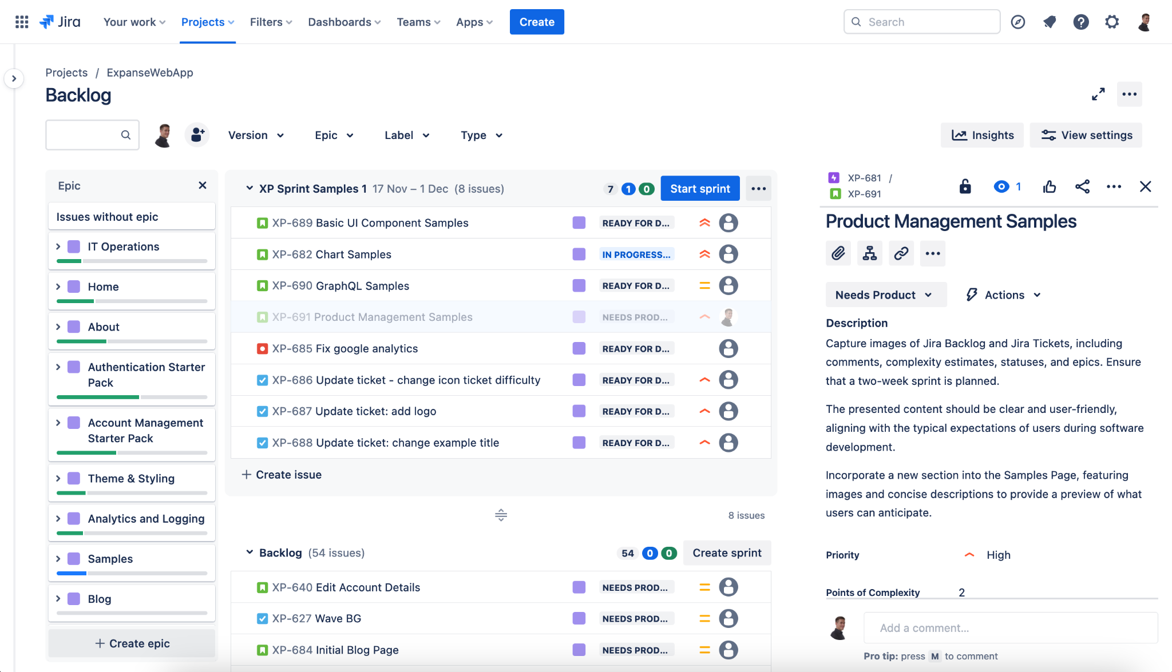
Example Sprint Board (Work In Progress) View
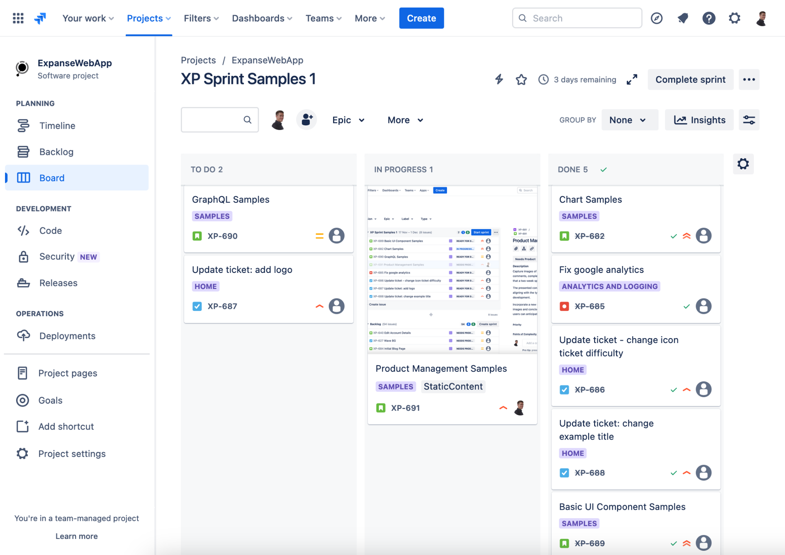
Disclaimer: Jira is a product of Atlassian utilized by me. I am not affiliated with them or endorsed by Atlassian.

Agile Ceremonies
To ensure smooth execution and continuous progress, I rely on a series of Agile ceremonies that help organize tasks, foster collaboration, and maintain alignment. These ceremonies are tailored to the needs of the project and may vary in frequency and intensity based on stakeholder involvement and complexity.

Daily Standups / Status Updates
Brief daily meetings or chat updates to discuss progress, roadblocks, and priorities for the day. These quick sync-ups ensure everyone is aligned and aware of any immediate challenges.
Sprint Planning
Before the start of each sprint, we plan the upcoming sprint’s work. Tasks are broken down, prioritized, and assigned based on capacity and complexity.
Backlog Grooming
Regular sessions to refine and prioritize the project backlog. These sessions involve revisiting tasks, clarifying requirements, and ensuring the most critical items are ready for development. Adjustments are made based on new insights and evolving priorities.
Retrospectives
At the end of each sprint, we reflect on the performance, identify successes, and discuss areas for improvement. This ceremony fosters continuous learning and evaluates alignment with goals.
Roadmap Meetings & Progress Updates
Depending on the project, I will hold roadmap meetings monthly, quarterly, or as needed to review high-level progress and revisit long-term goals. These sessions help align stakeholders, re-evaluate priorities, and ensure estimations remain accurate.

Boosting Engagement and Delivering Results with Agile
I'm a strong advocate for Agile development, particularly the Sprint and Story Point framework, because it fosters a highly engaged and productive environment, ultimately leading to better outcomes for everyone involved.

Sprints: Focused Iterations with Tangible Goals
Sprints provide short, focused iterations with clear, achievable goals. This approach allows for rapid adaptation to changing requirements and ensures continuous delivery of value. Unlike traditional longer development cycles, sprints allow for regular feedback and course correction, minimizing risk and maximizing the chances of delivering a product that truly meets user needs. The timeboxed nature of sprints provides a tangible, short-term goal, which can be highly motivating for teams.

Point Estimates: Complexity > Time
Point estimates provide a relative measure of effort, focusing on complexity rather than absolute time. This approach leads to more accurate estimations because it encourages the team to compare tasks rather than guess at hours. By focusing on complexity, we consider factors like risk, effort, and dependencies, leading to a more holistic understanding of the work involved.

Smaller Tasks: Enhancing Communication and Maintaining Momentum
Breaking down work into smaller, more manageable tickets has several key benefits. First, it facilitates more frequent opportunities for celebration of progress and helps maintain forward momentum. Second, the analysis and work required to estimate these smaller tasks helps uncover potential dependencies and complexities before development begins.This early identification of potential issues leads to more efficient development, fewer surprises, and more accurate communication with stakeholders. By reviewing features up front and estimating the relative size of a feature, we hope to uncover potential dependencies and complexities early on, leading to more efficient development and fewer surprises down the line.

Continuous Improvement and Collaboration
Regular progress updates combined with sprint reviews and retrospectives, creates a culture of continuous improvement. It helps enhance focus and motivation while boosting awareness and memory retention of progress while fostering a sense of accomplishment through measurable results. This translates to increased productivity and higher quality deliverables, faster time to market, and increased satisfaction for everyone involved.

I am confident that my expertise in Agile Methodologies can help take your organization/project to the next level. I'm passionate about helping teams achieve their full potential through effective Agile Practices.

